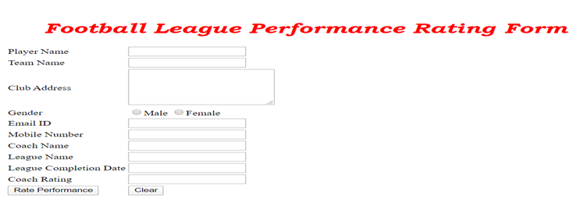

|  |  |  |  |  |  |  |  |  |  |  |  |  |  |  |  |  |  |  |  |  |  |  |  |  |  |  |  |  |  |  |  |  |  |  |  |  |  |  |  |  |
| --- | --- | --- | --- | --- | --- | --- | --- | --- | --- | --- | --- | --- | --- | --- | --- | --- | --- | --- | --- | --- | --- | --- | --- | --- | --- | --- | --- | --- | --- | --- | --- | --- | --- | --- | --- | --- | --- | --- | --- | --- |
| Design a Web page  “Football League Performance Rating Form” with the specified fields. | |  |  |  | | --- | --- | --- | | **Label Name** | **Component  Name** | **Description** | | Player Name | playerName | To enter the name of the player.  It should be mandatory. | | Team Name | teamName | To enter the name of the team.  It should be mandatory. | | Club Address | clubAddress | To enter the address of the player’s club.  Provide the correct tag and attribute to create a text area with 5 rows and 25 columns.  It should be mandatory. | | Gender | gender | Select the gender.  Provide the correct input type to make this component a radio button.  It should be mandatory. | | Email ID | email | To enter the email of the participant.  Use type=”text. Use “pattern” attribute to represent as valid email.  It should be mandatory. | | Mobile Number | mobileNumber | To enter the mobile number.  Use type=”text”. Use “pattern” attribute to accept whether the 10 digit mobile no starts with either one of the following numbers:  7,8 or 9  It should be mandatory. | | Coach’s Name | coachName | To enter the football coach’s name.  It should be mandatory. | | League Name | leagueName | To enter the name of the league for which the footballer’s ratings is being provided.  It should be mandatory. | | League Completion Date | leagueCompletionDate | To select the date of completion of the league.  Use type=”text. Use “pattern” attribute to accept the leagueCompletionDate  in the following  format :  mm/dd/yyyy  It should be mandatory. | | Coach’s Rating | coachRating | An auto-complete feature should be available to the user for the following options.  Excellent, Good, Average, Need Improvement, Poor  (Use DataList  with  id attribute’s value as “ratings” to make use of auto-complete feature with options  Excellent, Good, Average, Need Improvement, Poor).  It should be mandatory. | | Rate Performance | Submit | The input type submit must be used. | | Clear | Reset | Reset Button.  On clicking this button, all fields should be reset.  Provide the input type for this component. |    NOTE: All Tags, Elements and Attributes must be of HTML5 Standards (All Tags, Elements and Attributes should be specified in Lowercase). |
| **Apply the mentioned styles using CSS to the components** | 1.       Body color should be “#FFFFFF”.  2.       The heading should be done using <h1> tag, the text color should be “#FF0000”, font should be “Bookman Old Style”, style should be “italics” and it should be aligned to center of the webpage.  3.       The result should be bold and color of the text should be #0000FF.  (Do not use Inline CSS) |
| **Use JavaScript for displaying the feedback** | Use JavaScript for doing the following calculation:  When the coach enters the valid values and clicks the “Rate Performance” button, the performance rating for the player has to be displayed based on the following analysis :   |  |  | | --- | --- | | *Coach’s Rating* | *Performance Rate* | | Excellent | 5 | | Good | 4 | | Average | 3 | | Need Improvement | 2 | | Poor | 1 |    The result should be displayed as  “Performance rating of Mr/Mrs *playerName* is  *performanceRate - coachRating* ”  in a div tag with  id  “result”.  Note: Use getElementsByName() or getElementById()  function to retrieve the values. |
| **Form tag onsubmit** | Make sure  that the onsubmit attribute in the form tag is invoking the JavaScript function  like "return calculatePerformanceRating()". Also ensure that “return false;” statement is the last line of the JavaScript function “calculatePerformanceRating()”. |